Application Form
for
Presentation at SII 2024 of JCMSI Papers
* This is mandatory for all JCMSI paper who would like to present at SII 2024. Please to fill in this application form and submit it through IEEE PaperPlaza Management system
https://ras.papercept.net/
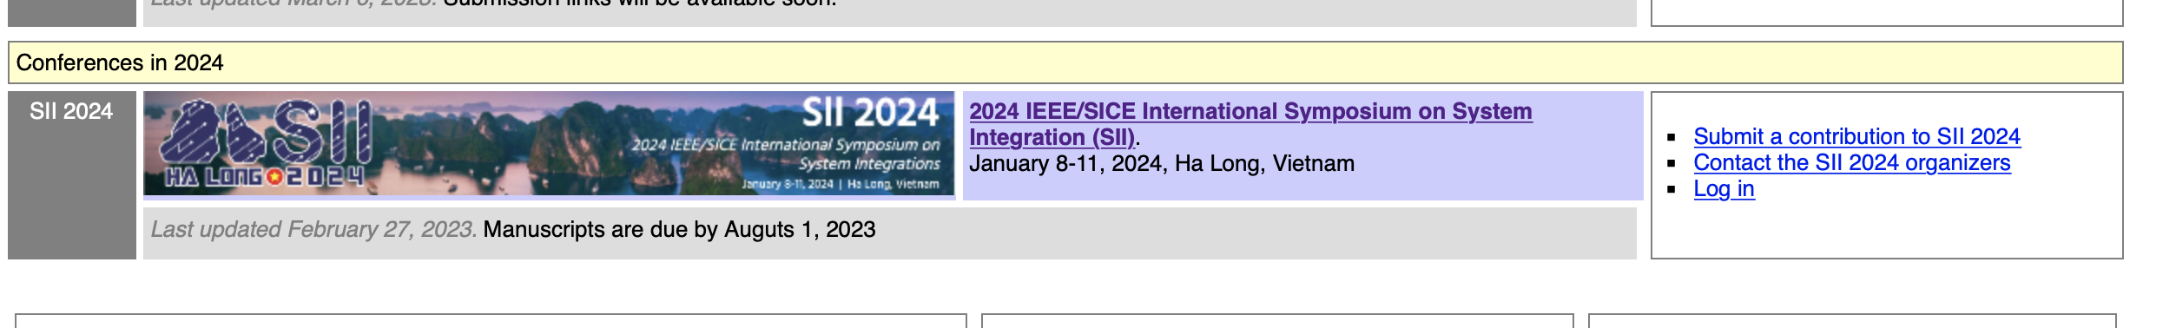
then click to “Submit a contribution to SII 2024”, from which you will see “JCMSI submission” and click “Submit”. From here, please follow neccessary steps for submitting the Application Form.
- Authors Information
- Author 1:
Name | First Name | Middle Name | Last Name
Affiliation
Email
Corresponding Author | ☐
- Author 2:
Name | First Name | Middle Name | Last Name
Affiliation
Email
Corresponding Author | ☐
(Feel free to add more authors using above template)

- Manuscript Information
Title
Abstract
This paper is now available online to access?
Yes ☐ |  |  |  | No ☐
URL/DOI |  |  |  | Please provide a URL for downloading the preprint version of the paper (using Google drive, Box, Dropbox or the likes)  URL: ...
Published Date

